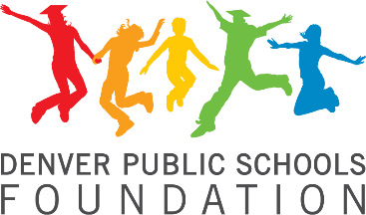

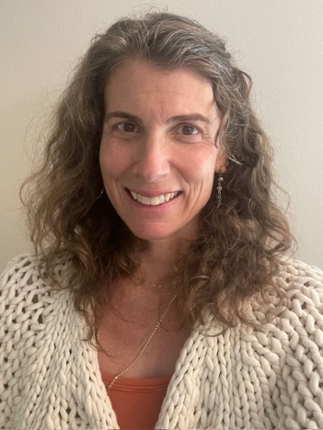

Rebecca Grant Zarret, Ed.D
Educator, Consultant, Coach
At Denver Public Schools Foundation, we believe that our city is strengthened by every student who graduates ready to lead a successful life. At the DPS Foundation, we invest in accelerating progress, we connect the community to our classrooms, and we inspire confidence in the promise of public education.
Rebecca Grant Zarret, Ed.D. is an education professional with nearly thirty years of experience in the field. Throughout her career, she has demonstrated a strong commitment to improving education in various capacities, spanning from early childhood education to K-12 to higher education. Currently, Rebecca's primary focus is on supporting the growth and development of leaders. As an executive coach, she leverages her expertise to work with school and district leaders across both public and private institutions, ECE-12, providing one-to-one coaching. In addition, Rebecca hosts and facilitates leadership team retreats and mindfulness retreats in Denver and at a private retreat space in Conifer, Colorado.
Before transitioning to coaching, Rebecca spent nearly a decade in school district administration, holding leadership roles in three large, urban school districts and serving as a consultant for schools, districts, organizations, and state-level institutions. This breadth of experience has equipped her with a comprehensive understanding of the challenges faced by educational institutions at various levels. She has also contributed to the academic development of aspiring leaders through her work as an instructor at the University of Colorado Denver, where for five years she has taught research methods to doctoral students in the education leadership program.
Rebecca's passion for supporting leaders was sparked during her time in Harvard University’s Urban Superintendents Program, where she conducted doctoral research on leadership and adult development. Her graduation from this program in June 2016 further solidified her expertise in these areas. She received her executive coaching certification from Northwestern University in 2020.
Early in her career, Rebecca taught middle school science in locations as diverse as rural northern California and New York City. These experiences continue to serve as a critical foundation for her leadership and advocacy work in education. In addition to her current roles, Rebecca actively contributes to civic life through her participation on the Board of Directors for the Denver Public Schools Foundation, Colorado Outward Bound School, Luminary Learning Network, and Ekar Farm and Community Gardens; she is also a member of the 50th Class of Leadership Denver. Rebecca lives in Denver, Colorado and enjoys adventuring with her husband and two sons, taking care of their abundant plant and animal life, and spending time in nature.

